

**FOSTER MANUAL**

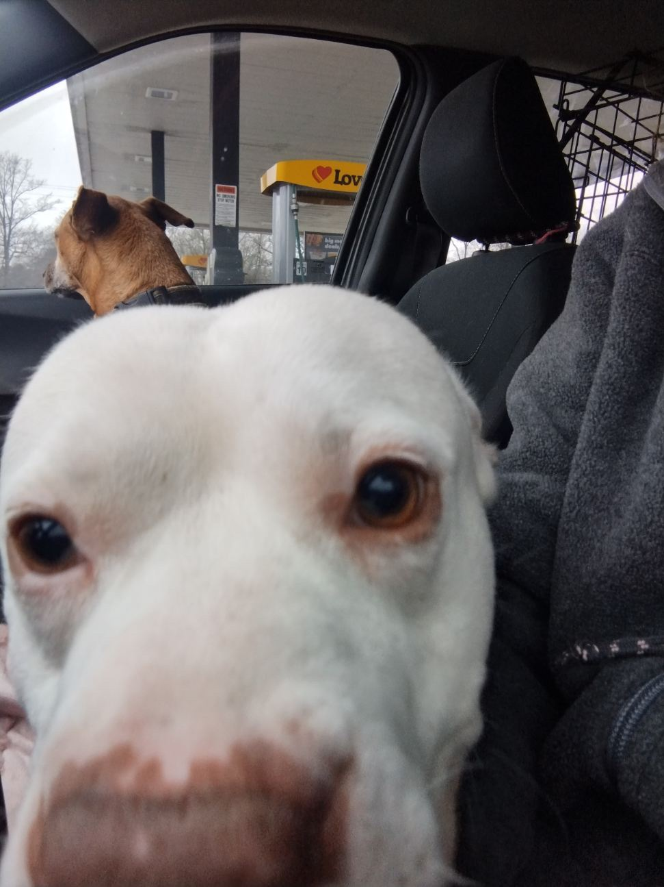

This manual is a compilation of many of the best parts of other foster manuals nationwide. Any reproduction of other’s authors works has been done so with permission of the original author. We scoured the nation to find the best of the best and it all has ended up here for your edification.

**#FostersSaveLives | #PFAFoster**

##### **Introduction to Foster Care**



Foster Dog Reno

**Welcome!**

Thank you for joining the PFA Foster Family! In becoming an active part of our foster care program, you are extending our shelter walls and offering our animals a new chance at healthy, happy lives in forever homes. You are helping to avoid unnecessary euthanasia, and you are providing us with valuable information to place animals in the homes best suited for them.

Foster parents give shelter animals a place to stay in their home until they are ready for adoption. As a foster, you agree to provide a safe area of your home (separate from existing pets) for your foster to stay. You also agree to provide food, socialization and transportation to PFA for medical care and to return your foster pet to the shelter (or discuss other options with the foster coordinator) when he or she is ready for adoption.

This manual is meant to build on what we go over in your foster orientation and provide you with information to help you care for your foster pets. It is also intended to explain the policies and procedures of Paws From Afar’s Foster Program. This manual is not all inclusive; PFA staff are available to provide further assistance as needed. Please do not hesitate to reach out to us if you have any questions, concerns, or feedback related to our foster program. We are here to help you.

**TYPES OF FOSTERING**

###### **Traditional Fostering (Adoption Ambassador) – THIS IS WHAT WE TYPICALLY UTILIZE:**

This is where you select an animal and it stays at your house and you help find its forever home.

###### **Short Term Fostering:**

Daytrips, Overnights or set period of times. Come up and take a dog out for lunch, maybe have it spend the night in your house or even just a week or two! Studies have shown any time away from the shelter really helps reduce an animals stress levels and reduced stress levels helps an animal be more adoptable! This also helps us market the animal (with your photos) and learn more about its home personality.

###### **Behavior Fostering**:

These animals need a little more help in learning to become the perfect house` guest. There areas of opportunity can range anywhere from just needing to learn how to reacclimate to living in a house to maybe they don’t get along with another species of animal and need to be kept separated from them.

###### **Medical Fostering:**

Animals with medical needs. These animals may be recuperating from surgery, treatments or any other variety of medical needs.

Examples of medical needs would be:

|  |  |
| --- | --- |
| Long-term medical needs | Short-term medical needs |
| * Ringworm – usually a 4-6 week commitment. As a foster, you would be asked to bathe pet(s) twice weekly with Lime Sulfur dip, give daily oral medication, and come back to the shelter weekly for rechecks. After fostering a pet with ringworm you will only be able to foster other ringworm positive pets until given clearance from our medical team. * Mange (non contagious) – usually a 2-3 month commitment. As a foster, you would be asked to give daily medications, bathe pet 1-2 times per week, and bring to shelter for rechecks every several weeks. * Broken bones – usually a 4-6 week commitment. These pets usually need to come in weekly for re- checks and may or may not need daily medications. Most have exercise restrictions and/or need strict crate rest. * Heartworm (non contagious) – usually a 2-3 month commitment. These pets need daily medication initially; then they come to the shelter monthly for heartworm treatment. They require crate rest/exercise restriction for the duration of treatment. * Extensive wounds – the time commitment varies from pet to pet, but most will need several weeks to months of foster care. These pets need frequent bandage changes, sometimes under sedation, so they may need to come to the shelter multiple times per week initially; then they may be able to go a week between bandage changes until cleared. They also may need medications given daily. | * Post-operative care – usually a 1-2 week commitment. These pets may need daily medications, warm or cold compressing of surgery site, suture/staple removal, etc. * Upper respiratory infections (kennel cough) – usually a 1-2 week commitment. These pets need daily medication(s), and depending on the severity may require other supportive care (such as subcutaneous – sub Q – fluids, special diet, etc.). * Pets in need of special monitoring for medical conditions, appetite, weight loss/gain, etc. The time/medical commitment will vary from pet to pet; this will be discussed on a case by case basis.   Bitsy from Alabama |

##### **Taking Home a Foster Pet**

When you are ready to foster a pet, schedule an appointment with a foster coordinator. Sometimes we will contact you when a pet/litter matching your request comes into the shelter, to minimize their length of stay. The foster coordinators will also send out email requests for pets/litters in the shelter who would benefit from foster care. If you are able to foster one of these pets/litters, you should email the appropriate foster coordinator to discuss placement.

Please note that not all pets in the shelter are available to foster, so you may see pets posted online or when you visit the shelter who may not be candidates for PFA foster care. Additionally, pets posted online may already be in foster care. For these reasons, please do not get your heart set on fostering one particular pet. Even if that pet has found placement there are many others in need. If you have questions about whether a pet is still available or in need of PFA foster care, please email your foster coordinator

When agreeing to foster a pet or notifying us of your availability, please be mindful of what you can realistically commit to. The commitment to foster a pet includes:

* The length of time you will have a pet. If you are only able to keep a pet for two weeks, a litter of 3 week old kittens/puppies or a pet with long-term medical needs may not be the best foster candidates for you at this time.
* The frequency of vet visits. Foster pets may need to come back to the shelter every 2 weeks for check-ups, vaccinations, etc. Other pets may require vet appointments every other day for serious conditions.
* Giving medications. Some pets going to foster require no medication, while others require medications every 12-24 hours. We will discuss this with you so that you can decide whether you are able to give the medications needed.
* Frequent feedings. Tiny bottle babies may need to be fed as frequently as every 2 hours throughout the day and night.
* Supplies and other expenses. Pima Animal Care will provide all vet care at our center; **we will also provide food, litter, and other supplies as we are able to – however, this is dependent on what we have donated at the time.** We may ask you to pay for food, litter, etc. out of pocket. If you are unable to do this for a large litter of pets, then please foster a smaller litter or single pet. (**Remember to save your receipts, often out of pocket foster expenses are tax deductible!**)

There will be some cases where pets will need to leave the same day that they come in (pets with ringworm or who need bottle feeding), or when an emergency comes up and you are suddenly no longer able to keep your foster pets. In these urgent situations, refer to the contact sheet, at the end of this handbook, for who to contact on days when a foster coordinator is not here.

When you come to pick up a foster pet, bring a leash/collar combo or a slip-style lead if you have one for adult dogs. Cats, kittens, and puppies must be transported in a carrier. Our pets should be transported securely in a vehicle, not a truck bed, and pets should not be removed from the carrier until they are safely in your home. You will also need to bring your driver’s license or other photo ID the first time you pick up a pet (this is not required every time).

Foster pets will be picked up from the Live Release/Coordinators’ office, which is next to our customer service area. Every time that you pick up a pet, you will need to sign a new Foster Agreement (copy included in this handbook). We will go over any medications/treatments, post-operative care, and/or appointments needed at this time.

##### 

##### Caring for your Foster Pet

Supplies: We will provide you with all medical care and medical supplies needed for your foster pet. When possible we will provide other supplies. **We will do our best to provide as donations allow, but we cannot guarantee to provide these supplies.** Please remember: Any money spent on foster care may be tax deductible as donations!

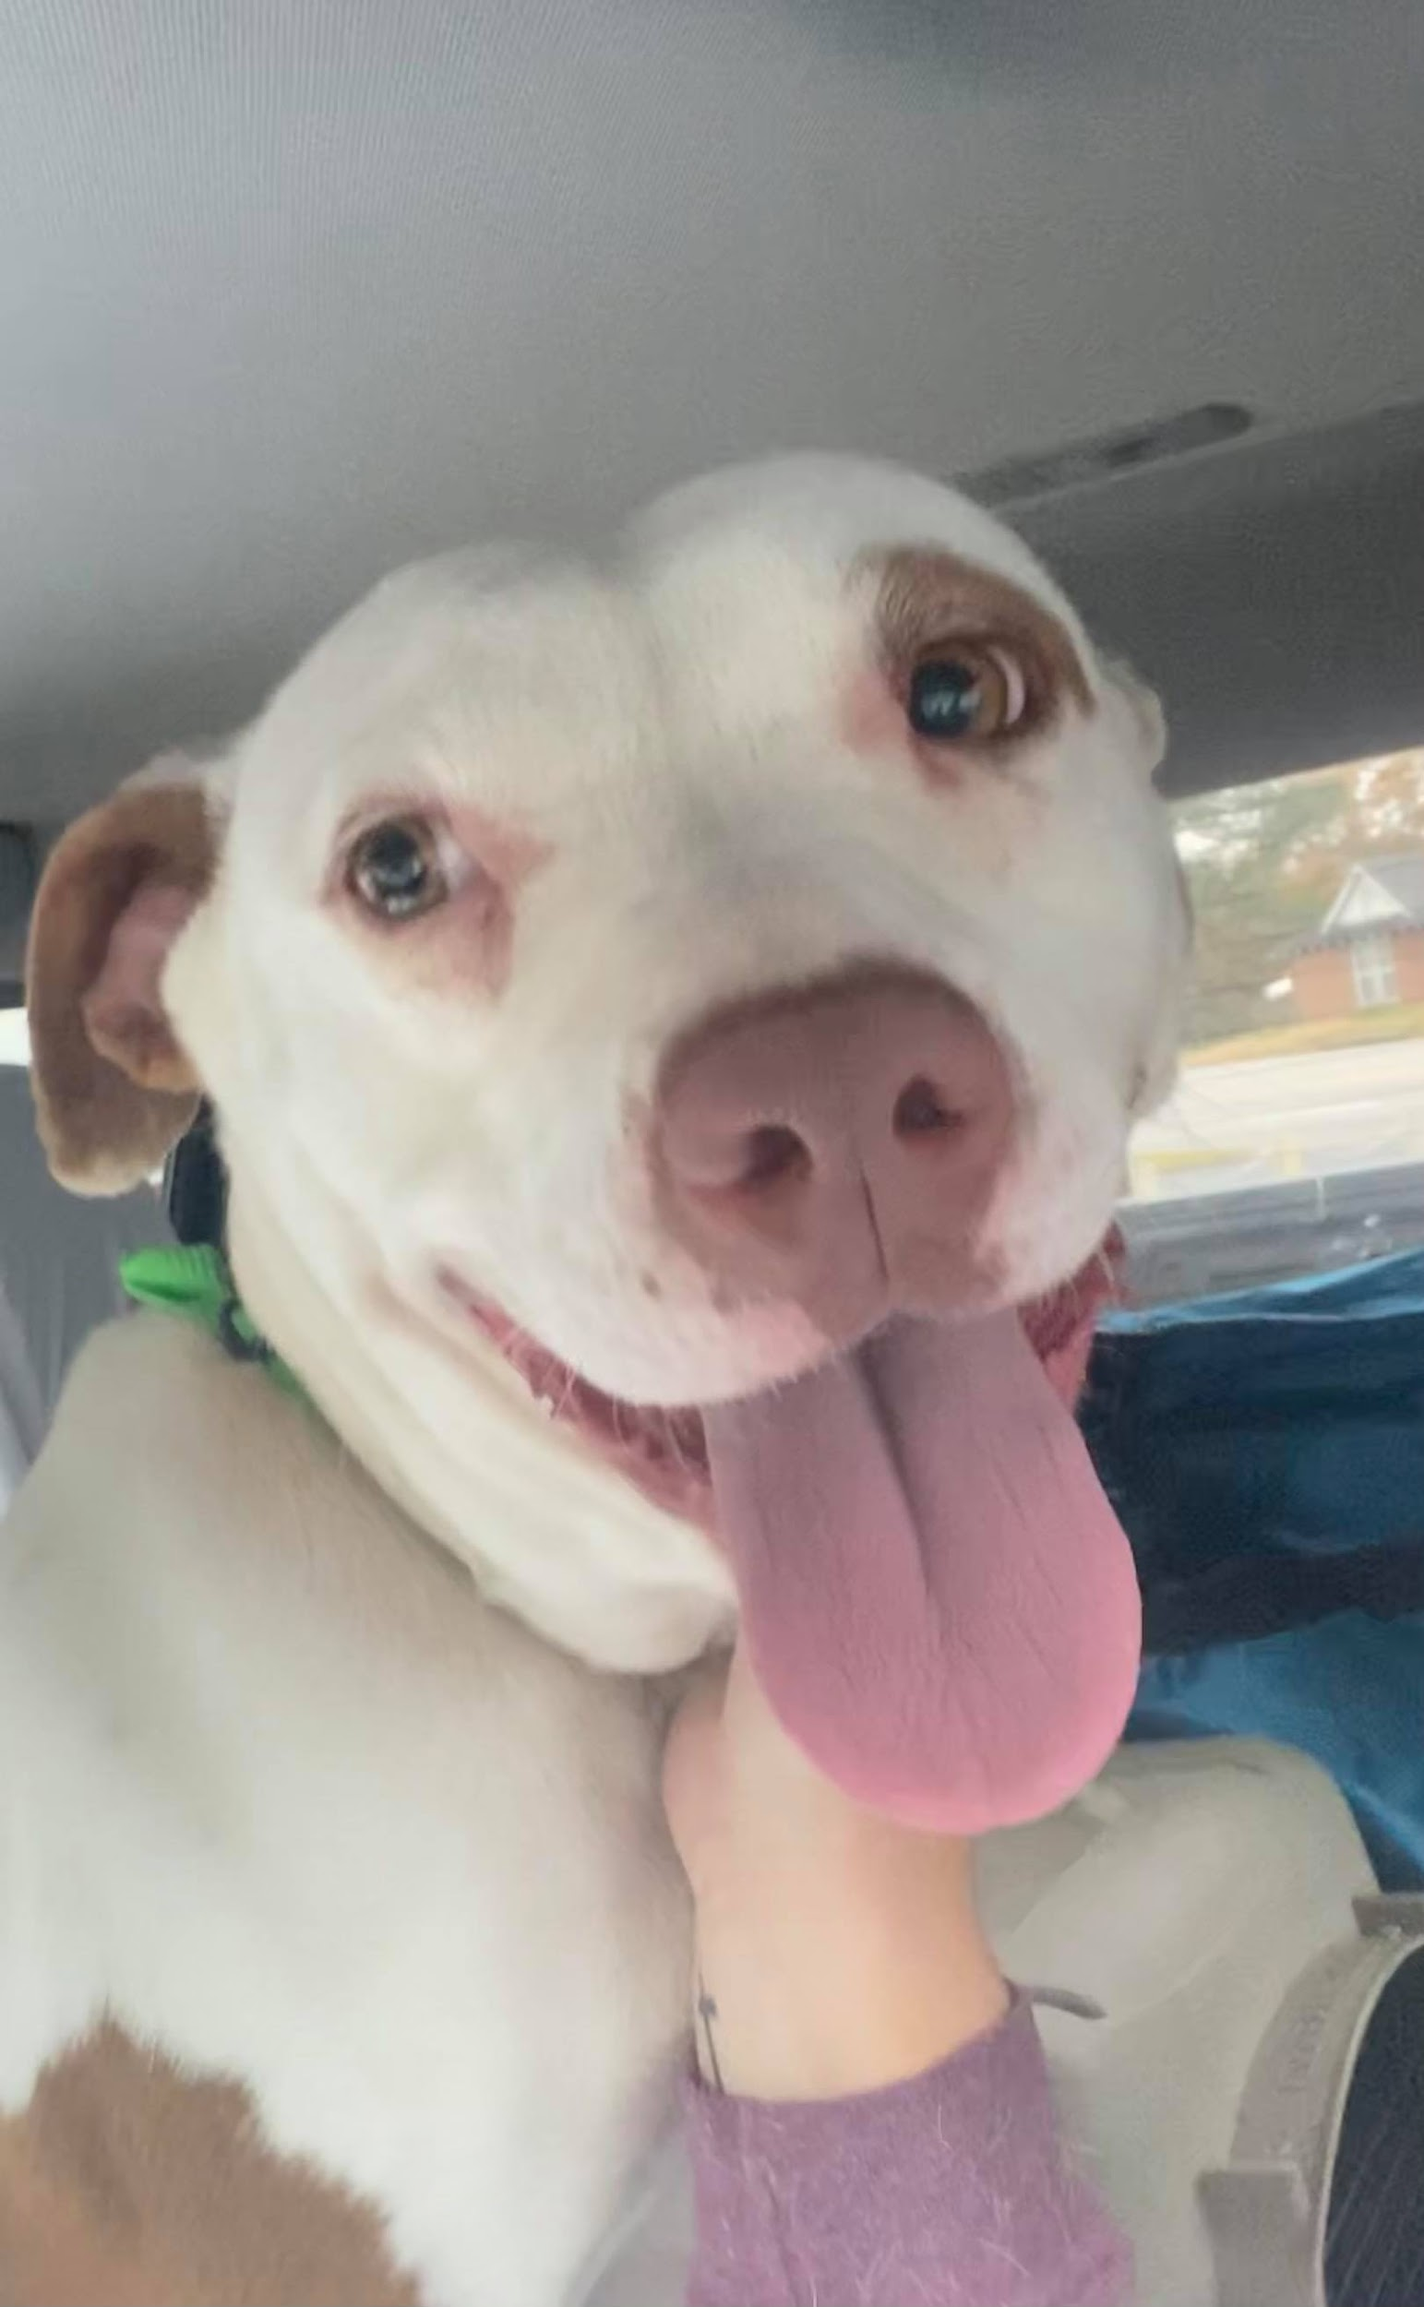



##### **Recommended Supply Checklist**

If there is something specific you are in search of let your foster coordinator know and we will keep an eye out on the donations for that supply and if we see it, we will set it aside and contact you. If we have it, and you need it… you got it!

But we have been foster parents ourselves! We know part of the fun of fostering is that first trip to the pet store to buy all sorts of pawsome things for your new foster! We completely understand that too!

|  |  |  |  |
| --- | --- | --- | --- |
|  | **Strongly Recommended** |  | **Not Needed – But may make your life easier!** |
|  | Food |  | Baby Gates |
|  | Food Bowl (For Food & Water) |  | Exercise Pen |
|  | Dog Food Storage Bin |  | Dog Brush |
|  | Food Scoop |  | Doggy Shampoo & Conditioner |
|  | Collar & Leash |  | Nail Clippers |
|  | ID Tag W/Phone # |  | Ear Cleaner |
|  | Crate |  | Enzymatic Odor Neutralizer |
|  | Dog Bed |  | Potty Pads |
|  | Poop Baggies |  |  |
|  | Toys (Hard & Soft) |  |  |
|  | CHEWS! (Rawhides not recommended) |  |  |
|  | Treats |  |  |
|  | Kong |  |  |
|  | Animal First Aid Kit |  |  |

##### Feeding

At the shelter, we feed adult dogs once daily in the mornings and leave dry food down for puppies, kittens, and cats at all time. Puppies and kittens also get fresh wet food several times a day. Very young kittens and puppies may also go home with formula. For litters of puppies and kittens, we recommend feeding separately at least twice a day to ensure that every puppy or kitten in the litter gets equal opportunity to eat (in some litters, more robust littermates may eat most of the food, leaving other littermates hungry). We avoid feeding generics to our pets, and we ask that you feed only good quality foods. No table scraps please.

When weaning puppies and kittens, make sure to have dry food available at all times for them to try. Canned food mixed with warmed water should be offered several times throughout the day; over several weeks you should use less water and begin mixing dry food in with the wet food until they are eating just dry food.

Fresh water should be available for your foster pets to drink at all times. We never offer cow’s milks, as dogs and cats cannot properly digest it.

##### **Grooming**

Please keep the pet clean, comfortable and safe. Remember: shampoos can be toxic to very young pets! Young pets can be bathed with 1 drop of Dawn dish soap (especially if they have fleas); water should be kept warm and they should be fully dried since young pets cannot regulate their own body temperature. If you notice fleas or ticks on your foster pet, please contact your foster coordinator to arrange for flea/tick treatment.

Any pets with undercoat, long hair, or mats should be brushed daily. Never use scissors to remove mats. Mats should be removed by clipper or a pet groomer.

##### 

##### 

##### 

##### **Housing**

We recommend keeping foster pets in an area that is isolated from your other pets, at least 2 weeks until the incubation period for diseases such as kennel cough, ringworm, etc. has passed; we want to minimize the risk to your personal pets. Our fosters have found that areas such as bathrooms, laundry rooms, use crates, baby gates or fenced in kitchens with tile flooring work well for housing foster pets. Try to use a space that is easy to sanitize (tile flooring – no carpet; no couches, beds, etc.) in case of ringworm, parvo, or other infectious disease.

If you are fostering a litter of puppies or kittens, keeping them in an area such as a playpen, whelping box, or children’s wading pool may help limit the area of “clean up” required. This type of enclosure will also allow you to make observations while providing plenty of room for a mother and her growing litter.

Remember: the environment must be sterilized between foster pets/litters to minimize risk of your new litter getting sick. Use 10% fresh bleach/water solution. A bleach solution loses its effectiveness if it sits for any length of time. If you have fostered pets with ringworm or parvovirus, you will only be able to foster pets with that condition until the environment has been sterilized and cleared by our medical team.

Dogs and puppies should be housed primarily indoors. **When taken outside, dogs must be leashed at all times unless in a fenced-in yard. Foster dogs should not be let outside unsupervised,** as they may try to escape the yard and head back to their original home. Dogs also should not be kept chained, tethered, or “tied out” in the yard as this is illegal in Pima County. Please do not take your foster dog to a dog park (or any place dogs are off leash), as we do not want to put our dogs in a position in which they might feel the need to fight with another dog or expose them to potential disease.

Underage pets must be kept off any public surfaces as they are not fully protected.

As with human children, puppies and kittens will play with anything they can find. Drapes, lampshades, table doilies, electrical cords and crystal ornaments may look like as much fun as the safe toys listed above. Take special care to puppy-proof and/or kitten-proof all areas in your home where fosters will have access. As your foster pet(s) grow, their climbing abilities will improve, so anything irreplaceable should be kept well out of reach.

##### **Socializing**

One of the most important parts of your job as a foster parent is to convince your foster pet(s) that humans are kind and loving. Some pets will adjust quickly to you and their new environment, but to some, you may seem like a strange and frightening giant! Be patient and allow your foster(s) time to acclimate to new surroundings. This may mean extra physical attention, or simply allowing the pet to explore on its own.

The principles of socializing are the same for all domestic dogs and cats: love them and they will respond. An outgoing, affectionate kitten or puppy can be cuddled and played with freely. The less social animals will need some encouragement (this is critical, as puppies and kittens have important socialization periods when they are weeks to months old. If they are not well socialized during this time, they may develop aberrant social behavior later):

|  |  |
| --- | --- |
| Crispin after Heartworm Treatment   * Try sitting on the floor with a timid puppy or kitten held against your chest, supported underneath and facing outwards, so it can’t see how big and scary you are. Stroke it and speak gently, telling it how cute and brave and fabulous it is. Continue this for about 30 seconds; then put the kitten or puppy down before it starts squirming. You want this to be a pleasant experience. The puppy or kitten will not be impressed, but if you cuddle it often enough, it will learn to love time spent   with you. | * Sometimes, holding a pair of young animals together helps—they seem to reassure each other. * If your puppies or kittens are fearful and run away from you when you approach, try sitting on the floor near them and let them come to you. This is a lot less intimidating to them than seeing a pair of big scary feet walking towards them. * There is no such thing as a bad puppy or kitten. Even if your litter doesn’t enjoy being held and cuddled, they may tolerate being stroked. As long as they don’t cower under the sofa, they will likely make someone a wonderful pet. Moreover, some of the most aloof puppies and kittens will grow up to be the friendliest, loving adults. * It’s never ok to punish a naughty animal. If one of your Puppies scratches and bites, it isn’t being spiteful or bad, it’s just a baby who doesn’t understand. Instead of punishing the animal, try distracting it with something else until it forgets about the bad deed it was doing—it doesn’t take long! * Discourage puppies and kittens from mouthing or biting your hands by distracting them with an appropriate toy. This will make them much more adoptable. Never engage in hand play with pets. * The less socialized adults may present more of a problem. Be ever-patient with scared animals. Be calm. Talk quietly. Move slowly. Sit low. The more approachable you are, the more likely a scared animal is to come out of its social shell. |

##### **Health and Disease**

###### **Vaccinations & Deworming**

|  |  |
| --- | --- |
| Your foster pet(s) will be up-to-date on age appropriate vaccinations and deworming at the time that you take them in. Puppies and kittens must return to the shelter every two weeks while in foster care to be weighed, dewormed, and have vaccines boostered starting at 4 weeks of age. Adult foster pets may or may not need to return to the shelter for vaccines. At the time that you pick up your foster pet, we will set an appointment for you to return for this. |  |

###### **Seeking Veterinary Care**

Many pets will head to foster with an established treatment plan for an existing medical concern (such as bandage changes, rechecks for broken bones, etc). We will do our best to ensure that any medical concerns are addressed prior to a pet leaving for foster. Please make sure to give all doses of medications and come to shelter for any required rechecks.

Pets coming from the shelter have been exposed to many germs, do not have an established vaccination history, and their immune systems may be suppressed due to shelter stress.

Therefore, it is not uncommon for a pet to become sick shortly after arriving in a foster home. Please watch for the following symptoms:

In puppies or kittens younger than 9 months of age:

* Diarrhea that last for more than a day
* Vomiting and diarrhea for more than 6 hours
* Vomiting more than once in an hour
* Not eating for more than 12-24 hours
* Lethargy without fever for more than 12 hours OR Lethargy with fever
* Sneezing, coughing, and/or goopy eyes
* Areas of crusty skin and/or hair loss
* Lameness paired with discomfort pain In adult dogs or cat
* Not drinking for more than 24 hours
* Diarrhea that lasts for more than 1-2 days
* Vomiting more than 2-3 times in an hour
* Not eating for more than 72 hours
* Lethargy without fever for more than a day OR Lethargy with fever
* Sneezing, coughing, or goopy eyes
* Lameness paired with discomfort or pain

If you notice any of these symptoms, please contact your foster coordinator immediately for guidance and/or an appointment to bring them in to be checked by the vet. Remember that PFA provides all veterinary care onsite at no cost to you, but **if you go to an outside veterinary clinic you will have to pay for the visit yourself and will not be reimbursed (but it may be tax deductible)**.

The sooner your foster pets get checked by a vet, the more likely they are to recover well. Our vets see appointments onsite 7 days a week from, Deb needs to schedule all appointments.

Emergencies can be seen outside of these office hours, but please contact your foster coordinator first. Kittens or puppies in a litter initially appearing healthy may begin to “fade” (stop growing, losing weight, and/or stop eating). If you notice your foster kitten or puppy fading, please contact us immediately to be seen by a vet.

Emergency situations may include:

* Continuous diarrhea coupled with lethargy
* Continuous vomiting
* Bleeding of any kind (from the nose or mouth or in urine/stool)
* Any trauma such as being hit by a car, dropped, stepped on, etc.
* Seizures
* Difficulty breathing

If your pet is exhibiting any of the above symptoms during business hours, please bring your pet to the clinic to be seen by our vet.

###### **Protecting your resident pets**

As mentioned previously, pets coming from the shelter have an unknown medical history and may be contagious to other pets. As such, **all resident pets should be fully vaccinated before a foster animal enters the home**. We strongly recommend that you keep your fosters separate from your resident pets at all times for at least the first 14 days and disinfect the environment before allowing resident pets into areas that foster pets have been in. You should never leave your resident pets and fosters alone together for any amount of time.

Protecting yourself: Animals can carry diseases that are transmittable to humans. These are especially common in stray pets or pets coming from a shelter. To protect yourself from these diseases, everybody in the home should:

* Wash hands before and after handling animals.
* Use protection when cleaning feces and other animal-related messes.
* Disinfect with a 10% fresh bleach-and-water solution. All areas (floors, walls, furniture, etc.) and materials (bedding, toys, litterboxes, dishes, etc.) that have come into contact with foster animal(s) must be bleached before being used for new foster animals.
* Use ceramic, glass, or stainless-steel food/water dishes for easy disinfection.
* Be aware that animals can carry disease without exhibiting symptoms. Use the same precautions with a healthy-looking animal as you would with a sick one. Make it a habit to practice good hygiene at all times, including washing your hands thoroughly with hot water and antibacterial soap after handling your foster animals.
* Be familiar with the disease information provided in this handbook and be sure to let your physician know that you work with shelter animals.

###### **Submitting for Reimbursement**

In order to submit for reimbursement, please send your receipts to [Deb@pawsfromafar.org](mailto:Deb@pawsfromafar.org) include the name of the dog that you are fostering. Make sure you add your preferred method of payment – PayPal, Venmo or Zelle

###### Pet Poison Control Charthttps://www.1800petmeds.com/education-data/images/pet-poison-control-chart.jpg

##### **Dog to Dog Introductions**

|  |  |  |
| --- | --- | --- |
| There may be a number of situations in which you would introduce your dog to another dog. Examples are walks in the neighborhood, hiking in a park, dog sitting for a friend, fostering a dog from the shelter, etc. For whatever the reason we need to understand that not all dogs will be best friends and some dogs just aren’t very social at all. Safety should always be your primary concern (for you and your dog/s), though accidents will happen and we can not always prevent them. Always work within your comfort zone. If you are uncomfortable about any given situation, stay away from it, if at all possible and seek the help of someone with more experience to help you through the situation.  Every situation may be different, so always be aware and pay attention to what your dog is doing. It may not be your dog in the wrong, but you don’t want them to have a bad experience.  Some of the biggest errors in the handling of dogs is having a tense leash. If your dog cannot approach another dog calmly to greet them, then you will need to work on that separately from the walk. | | |
| **Introductions on a casual walk/hiking:** |  |  |
| 1. If you encounter another dog out   on a walk, always ask the owner if you can greet their dog. If yes, continue to the next step. If no, try again another day.   1. In order for two dogs to greet, the dogs must be relatively calm (not excited and pulling). If either dog   is excited and pulling, it would be safest not to greet at that time. Work on calming skills and having  your dog focus on you and try again another day.   1. Once your dog is relatively calm and has good focus, I like the three second rule. Have the dogs greet one another so their noses and rear ends are together so they can smell each other. The entire process should not take more than three seconds. After three seconds, you   want to mark the pleasant encounter by saying “yes” (or whatever your mark happens to be) | and offering a treat away from the  other dog making encouraging sounds. Try your best not to pull on the leash, though a light tug make be necessary, if the treat does not work.  A dog sitting on a bed  Description automatically generated  *Foster Dog Finn*  4. You will be able to extend the time your dog interacts with that particular dog with each encounter.  Brief encounters are always better than extended ones. | We want our dogs to have pleasant  experiences with nothing bad happening.   1. There will be times when two dogs appear to be best friends with the first greeting. Even though   they get along great it is far better to keep the encounter short and arrange a play date in a neutral  area, so they can play off lead and not be tangled with leashes. Meeting in a neutral area eliminates  the possibility of one of the dogs guarding familiar territory.   1. Always supervise the play, if the play starts to escalate just step in and give them a break. You can add   a command cue like “time out” each time you step in. |

##### **Decompressing Your Foster Dog**

|  |  |
| --- | --- |
|  | **Decompressing Rescue Dog**  April 6, 2014  Source: roanokeadoptablepounddogs.wordpress.com  **Decompression Phase**  When adopting or fostering a rescued dog from the shelter, it’s a happy time for you and a relief to the dog. For one, you’ve taken them away from that loud, scary place. As the new owners or foster of the dog, you’re also excited because you’re bringing in a new member of the family into your home. This new situation is exciting for everyone with new interactions and adventures to come.  BUT WAIT! Before you go showing off your new pet to your family, friends, and resident pets, please give the new dog time to relax for a while. The last thing you should do at this point is rush them into a whole new dramatic situation and making them interact that could get them into trouble if they’re not ready for it.  Think of it like this way as humans; you’ve been looking desperately for a job to support your family; you’ve been looking for over three months, your savings is dwindling fast, and you’re worried; VERY worried. You’re getting up every day looking at the paper/internet, going to interviews, and finally you get a job.  First day on the job, you’re excited but nervous, and just want to feel your way around. Then, some co- worker’s trying to make you look bad; trying to push  your buttons. You want to do the right thing but if no one gives you time to know your job and no one’s controlling the guy harassing you, things could happen and (you’re back at the shelter) you’re fired; or, worse, in jail, depending on the reaction. This is just my interpretation as we don’t know the feeling of being in doggie jail just because we’re a dog, but I bet I’m close. When volunteering at a shelter you see this stress all the time. |

|  |  |
| --- | --- |
| **Decompress for at least 3-5 days.**  A large brown dog lying on a sofa  Description automatically generated  Dogs that have been at the shelter for an especially long period of time need to decompress and get themselves back into a calm state of mind; unlike the worrying and stressing when they were at the shelter.  I had a foster dog once that seemed to be normal at the shelter but wouldn’t make much eye contact. When I got her home, her eyes seem to be darting everywhere but at me. It was odd; I thought she was “special”, or just weird.  I knew she was still kennel-stressed from being at the shelter. It took a couple weeks for her to get over that and get back to herself and finally making eye contact. | Basically, I created a routine taking her for walks in the morning and playing ball afterwards, then I’d put her in the crate to rest for a couple hours. I’d give her something to do, such as a filled kong or some type of dog-friendly chew toy to get her mind working. When she returned to being herself, I introduced basic training such as “Look”, “Sit”, “Down”, and “Come”; all the while I kept her separate from my own dogs. Whenever I felt ready, I slowly introduced her to my own dogs by taking them out on walks together outside the home.  It’s always best to introduce the dogs away from the home (such as on a walk or at a park) to get acquainted.  The next step, after they seem to get along on the walk, is to let them socialize in the backyard. When that’s successful, then you can let both the new/foster dog into the home along with the resident dog(s) together….but only if YOU feel comfortable with it. If you’re the least bit hesitant about it, DON’T DO IT. Dogs can sense when  you’re uncomfortable, and one or the other may feel they have to protect you or other family members. If, at any moment, that something does happen, go back to the previous step until there’s no worry or hesitation.  Decompression time varies with each and every dog. Some need more time than others, but it’s safe to recommend at least one week is best for the new dog. Always treat the dog with respect and give them guidance, exercise (dogs walks, playing), and bond with them. If after the decompression phase, the dog starts to show behavioral problems, start to address it with training to get him/her to listen to you and gain that respect. If you need to consult with a dog trainer, that’s what you should do; or ask your family/friends if they’ve had situations like this, and what they did; or look online for articles/video that may have the answers you need. One of the top reasons dogs end up at the shelter are because their owners didn’t train them, or rarely interacted with them. |
| NUMBER ONE RULE: keep your new dog/foster in a crate during decompression time, and always when you’re not home. After decompression, and everyone’s acquainted and comfortable, it’s up to you, as the owner, to take responsibility to determine if your pet can stay free in the home, or if they should be crated.  Perish the thought you should come home and find a disastrous situation because you left your animals unattended to make their own decisions. Not to say it can’t work, but you have to be certain it can; if not, crate them. | |

##### **Decompression Checklist for Foster Dogs**

When a dog suffers from kennel stress, it can take from several minutes to 48 hours or more for that pet’s anxiety to

return to near normal levels. It takes time to build trust, and trust is the basis for obedience. The more a dog trusts it’s foster, the more likely it will follow the rules.

In some cases, the buildup of shelter stress can make a dog difficult to tire out. This will improve with time, but there are several things a foster should do to make this process go smoothly.

|  |  |  |  |
| --- | --- | --- | --- |
|  | Prepare needed supplies in order to engage your foster dog mentally. You may want to use food-filled frozen Kongs, puzzle toys, etc. | **Other Suggestions for Decompression:**   * If it’s not possible to take the dog into foster right away, it will help if the foster comes to the shelter to bring the dog treats or take it outside several times. Consider leaving something with your scent on it, such as a towel, with the dog while it’s there. This may help the dog to feel more comfortable and associate the foster with good things. * If the dog is anxious, use a pheromone diffuser or collar, or diffuse some essential oil of lavender into the air. | |
|  | If this is your first time outside of the shelter with your foster dog, take a walk around the shelter grounds for 10-15 minutes before leaving to get comfortable with the dog |
|  | Continue walking, either at the shelter, a park or in your neighborhood until your foster dog appears to relax. |  | * Consider only using essential (safety-related) commands during the first 24-48 hours. Don’t want the dog to jump onto your couch while jumping around the house? Think about saving that lesson for another day when they are more calm and available for learning, and engage your foster in another   task that’s incompatible with jumping on the couch, like a game of Box Hide and Seek.   * Make sure your activities don’t overstimulate the dog. * If the time of day is flexible, fosters should consider taking a dog right after it’s been expending energy in the shelter’s play group—just don’t   skip the long walk! |
|  |  |
|  | When you arrive home, ensure that any family members who are meeting the dog for the first time are seated. They should let the dog come to them for attention, as opposed to soliciting attention from the dog. |
|  | Keep your foster dog separated from your own dogs until your foster is visibly relaxed. |
|  | If your foster is unable to settle down (panting, whining, constantly in motion, etc.) channel their energy into a task such as fetch, puzzle toys or any game that engages their brain  until they are able to relax. |
|  | Do only essential meet-and-greets for the first 48 hours to week, depending on the dog’s comfort level. | * If the dog is fearful and you’re walking in a place that’s not public, consider walking with a longer leash so that the dog doesn’t need to be closer to you until it’s more comfortable. * Consider playing soft music. Classical, reggae and ambient electronic work well for helping pets decompress. * Try to stick it out for the first 24 hours. It will get better, we promise! | |

### **Body Language of Canine Anxiety**

